Step-by-Step Guide to Apply Texas
- Create an account at www.goapplytexas.org
- Start/Edit your profile
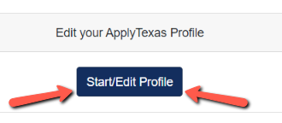
  - Enter your personal information
  - On pg. 5, you only need to enter a Physical Address if it’s different than the Permanent Address you entered on pg. 4.
- Pg. 8 – High School Information. If you are homeschool, enter the name in the Search box, select “Homeschooled, TX (US)” from the list like the image below:
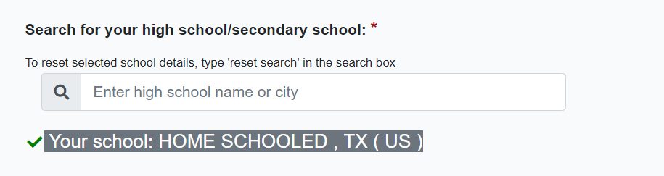
  - Enter your approximate Graduate Date ex. 06/01/2023, 06/01/2024, 06/01/2024
  - A GED only applies if you drop out of high school.
- Pg. 9 – No, you’ve never taken college classes.
- Pg. 10 – Question about how long you’ve lived in Texas: By the time you graduate high school, will you have lived in Texas during 10th, 11th, and 12th grade?
  - If you answer yes, you’ll only see two additional questions.
  - If you answer no, you will see additional questions about parent/legal guardian.
  - Once you’ve answered all the questions, click Done.

- On the Apply Texas home page, you will now select “Start/Edit Applications”
- Then select Start a New Application
- Select Two-Year Community College
- Select Collin County Community College District
- Select Application Type: Dual Credit
- Select Fall 2022 (or Summer 2022 if you plan to start taking classes this summer)
- Select your Major (it does not matter what you choose).
- Then scroll down and choose Select Choices and Start Application
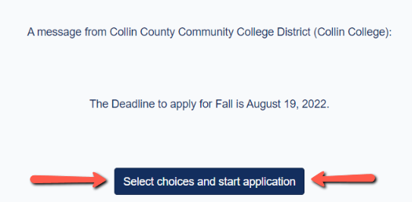
- Then scroll down and you’ll see the box for Collin College application. Click the “+ Admissions Application”
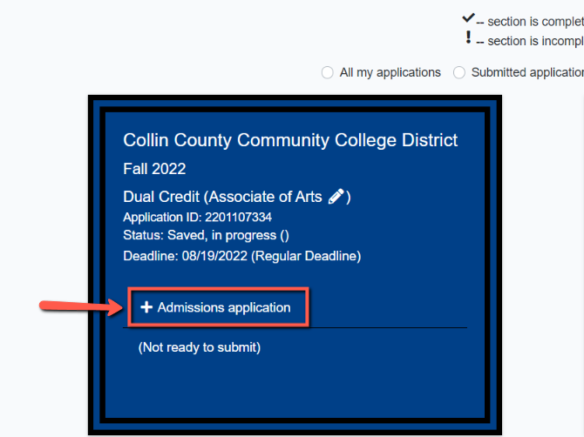
- Notice the guide at the top:
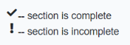
- Select Dual Credit Questions
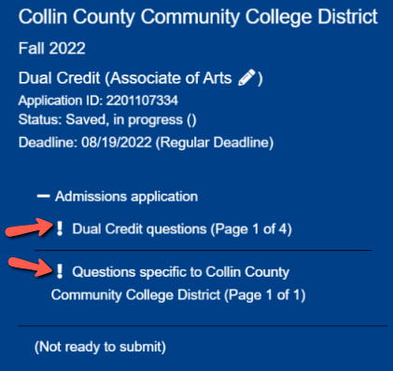
- Answer the questions on pg. 1
- Select “Dual Credit” from the drop-down menu, and then select either “Earn an Associates” or “Earn Credits for Transfer”
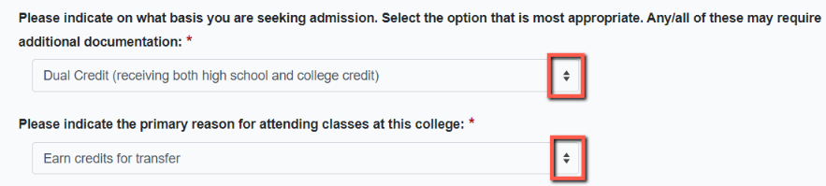
- Click the arrow on the pg. 2 and 3
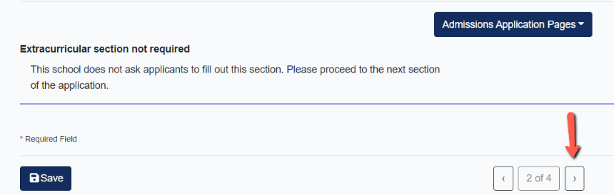
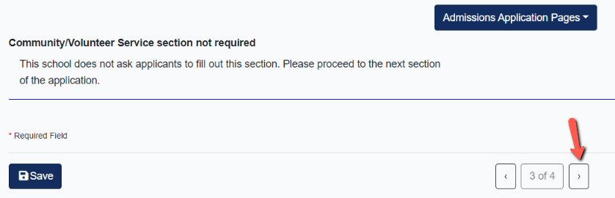
- Pg. 4 – Click Done. You’ll be taken back to the home screen. Scroll down.
- Select the “+ Admissions Application” and then select “Questions specific to Collin”
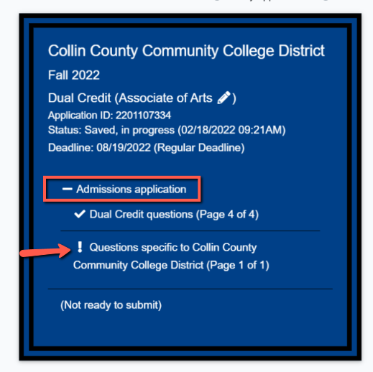
- Answer question and then click Done – BUT you’re NOT done!
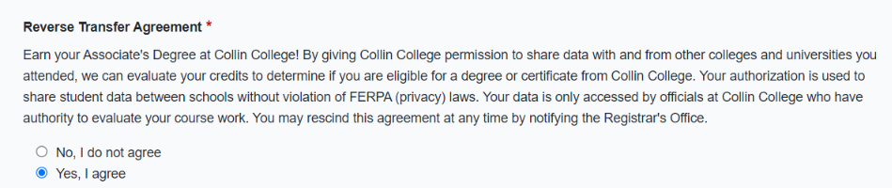
- You’ll be directed back to the home page. Scroll down and select Submit This Application
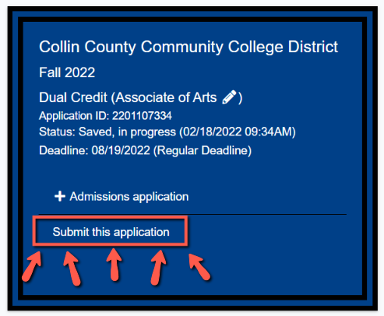

- You know your application has been submitted when your screen rains confetti on you.

